**Food safety and public health issue in Bangladesh**

**Introduction:**

In Bangladesh, most food products, whether manufactured or processed, are not safe to eat or some are counterfeit. This problem exists at all levels of the food chain, from preparation to consumption. Food manufacturers, processors, restaurants, fast food restaurants, and everyone else are somehow involved in this corrupt and counterfeiting behavior. On the one hand, foods containing a variety of harmful chemical substances and toxic artificial colors are forged, and spoiled, perishable, and toxic foods are stored, sold and distributed to consumers. Unsanitary and unsafe food handling seriously affects public health. Cause many chronic and non-chronic diseases. Failed to resolve the ongoing food security challenges in Bangladesh. A poll conducted by the Institute of Nutrition and Food Science of the University of Dhaka in the early 1980s found that 60% of the malnourished population in Bangladesh was caused by ​unhealthy diets and the use of counterfeit food. The Bangladesh Public Health (IPH) and the World Health Organization (WHO) in Dhaka evaluated 52 street vendors in their joint study of counterfeit food items in 1994 and found all food items from these vendors the samples are contaminated with various types of pathogens. In 2003, another study conducted in the capital by the same organization as the last time showed that among 400 types of candies, 250 types of biscuits, 50 types of bread, and 200 types of ice cream, 96% of candies, 24% of biscuits, and 54% Of bread and 59% of ice cream are fakes. This study found that in the past few decades, approximately 50% of the food samples analyzed by IPH laboratories were counterfeit. Counterfeit food has many fatal effects. The National Working Group on Food Counterfeiting (NTFS) established by the government of Bangladesh found that counterfeit food causes a variety of food-borne diseases each year, including diarrhea, malnutrition and other diseases, resulting in deaths. In Bangladesh, unsafe foods as adults are the main cause of death among children.

**Major Foodborne illnesses and causes:**

Foodborne diseases are usually infectious or toxic, and are caused by bacteria, viruses, parasites, or chemicals that enter the body through contaminated food or water. Foodborne pathogens can cause severe diarrhea or debilitating infections, including meningitis. Chemical pollution can cause chronic diseases such as acute poisoning or cancer. Foodborne illness can cause long-term disability and death.

**Bacteria:**

**Salmonella, Campylobacter and Enterohemorrhagic Escherichia coli** are the most common food-borne pathogens, affecting millions of people every year, sometimes with serious and fatal consequences. Symptoms: fever, headache, nausea, vomiting, abdominal pain and diarrhea. Salmonellosis includes eggs, poultry and other animal products. Foodborne Campylobacter infections are mainly caused by raw milk, raw or undercooked poultry, and drinking water. Enterohemorrhagic E. coli is related to unpasteurized milk, undercooked meat, fresh fruits and vegetables.

**Listeria** infection can cause miscarriage of pregnant women or death of newborns. Although the incidence of this disease is relatively low, Listeria has a serious and sometimes fatal impact on health, especially in infants, children and the elderly, and is one of the most serious food-borne infections. In non-pasteurized dairy products and various ready-to-eat foods, it can be grown at refrigerated temperatures.

**Vibrio cholerae** infects humans through contaminated food or water. Symptoms include abdominal pain, vomiting, and severe watery diarrhea, which can lead to severe dehydration and possible death. Rice, vegetables, millet porridge and various shellfish have been linked to the cholera outbreak.

### **Viruses:**

Norovirus infection is characterized by nausea, explosive vomiting, watery diarrhea, and abdominal pain. The hepatitis A virus can cause long-term liver disease, usually spread through raw or undercooked seafood or contaminated raw food. Infected grocery stores are often the source of food contamination.

### **Parasites:**

Some parasites, such as fish leeches, can only be spread through food; others, such as tapeworms, such as Echinococcus or Taenia solium, can infect humans through food or direct contact with animals. Giardia enters the food chain through water or soil and can contaminate fresh food.

### **Prions:**

Prions are infectious agents composed of proteins, which are unique in that they are related to certain forms of neurodegenerative diseases. Bovine spongiform encephalopathy (BSE or mad cow disease) is a prion disease of cattle and is related to a variant of human Creutzfeldt-Jakob disease (vCJD). For example, eating beef products that contain certain risk substances. Previous. Brain tissue is the most likely way for prions to spread to humans. [1]

## **Chemicals:**

The biggest health risks come from natural toxins and environmental pollutants.

**Naturally occurring toxins** embrace mycotoxins, marine biotoxins, toxic glycosides and toxins occurring in toxic mushrooms. Staple foods like corn or cereals will contain high levels of mycotoxins, similar to biological weapon and ochratoxin, created by mould on grain. A long-run exposure can have an effect on the system and traditional development, or cause cancer.

**Persistent organic pollutants (POPs)** are compounds that accumulate in the environment and the human body; well-known examples are dioxins and polychlorinated biphenyls (PCBs), which are undesirable by-products of industrial processes and waste incineration. Accumulate in the environment and in animals. Dioxins in the food chain are highly toxic and can cause reproductive and developmental problems, damage the immune system, disrupt the production of hormones and cause cancer.

**Heavy metals** such as lead, cadmium, and mercury can cause nerve and kidney damage. The heavy metal load in food is mainly caused by air, water and soil pollution. [1]

Non-food grade chemical additives (such as dyes and preservatives) and contaminants (such as pesticide residues) have also been found in food sold on public roads. Chemical analysis of food sold on public roads in Bogor revealed unauthorized dyes such as textile dyes and pesticide residues. The correct use of salt, spices, nitrates and sugar is an important tool to prevent food spoilage, but low prices can lead to cheap ingredients and unapproved chemical additives from unapproved suppliers. Added to mask the low quality of cheap materials.

Due to the conditions for selling food on public roads, there are concerns that food may be contaminated by heavy metals and pesticide residues. This pollution may come from the equipment used, raw materials or transportation methods, or it may come from the lack of suitable storage facilities.

### **Microbiological Safety:**

Due to the globalization of the food market, climate change and continuous changes in human consumption patterns, people prefer fresh and convenient foods, so the fight against food-borne diseases is facing new challenges. Microorganisms and food-borne diseases are the result of ingestion of contaminated food and food. More than 250 different types of viruses, bacteria, parasites, toxins, metals and prions are related to human foodborne diseases. 50% of foodborne illnesses; usually, hospitalizations and deaths related to foodborne infections are caused by bacterial pathogens. Infections range from mild gastroenteritis to life-threatening neurological, liver, and renal syndromes caused by pathogenic microbial toxins or the body's response to the microbes themselves.

Foodborne bacterial pathogens are the main cause of serious and fatal foodborne diseases. Among thousands of different types of bacteria, more than 90% of food poisoning diseases are caused by Staphylococcus, Salmonella, Clostridium, Campylobacter, Listeria, Vibrio, Bacillus and enteropathogenic Escherichia coli. [2]

**Main food safety issues in Bangladesh and their impact on public health:**

The World Health Organization (WHO) expressed its concern on the impact of food safety on Bangladesh's public health on its website. It shows that the unsafe product may be the main cause of many chronic and non-chronic diseases, including but not limited to diarrhea, cancer, heart disease, various kidney diseases and birth defects. Its potential specific public health impact.

### **Personal Hygiene:**

Buying ready-to-eat foods and ingredients from street or market vendors poses a major public health risk, especially due to poor hygiene. Some sellers sleep in retail stores to protect their groceries, groceries and ingredients, and are also exposed to repeated contamination of unwashed hands and packaging materials such as bed sheets, old newspapers and reusable plastic bags.

However, many retailers are aware of the need to wear clean, appropriate clothing. Some salespeople wore hats and aprons. After some information campaigns for sellers, most people understand that they need clean clothes and tableware. However, because there is no water supply system near the workplace, the sewage treatment system is also very poor, which means that they cannot maintain good hygiene habits, and some grocers put their hands in the same bucket for washing dishes, which may cause food to be affected by feces. Pollution. On the other hand, most grocery retailers operate their business without a health certificate or permit, which raises additional concerns and requires extensive training programs in food preparation and processing techniques.

Street vendors use soap that is cheaper than liquid soap. Liquid soap can wash dishes more effectively, but because they use cold water, cleaning results in poor cleaning results. Cardboard that causes the printing plate to be contaminated again. [2]

### **Environmental Hygiene:**

Insufficient waste treatment facilities can lead to the accumulation of waste at food points, an increase in the number of pests, and an increased risk of food contamination. Therefore, services such as garbage collection are not available. City officials often face a dilemma: If they provide services for illegal transactions, it means that these transactions will be recognized. At the same time, because sales are illegal, and sellers are not. It helps to maintain infrastructure or provide public services that they are not entitled to benefit, which further worsens the sanitary conditions in food sales areas. Street vendors have also contributed to poor food storage and transportation conditions. Groceries, cornmeal and other spices from official stores, so the safety of this raw material is not of much concern. However, most suppliers do not have a fixed kiosk and they can store raw materials on site. The goods stay at home overnight and are transported to the workplace the next day, usually improperly packaged. This makes food susceptible to contamination during transportation. [2]

**Unhygienic Practice in Food Handling:**

The food industry in Bangladesh generally handles unhygienic food. Countless restaurants and fast-food restaurants prepare, bake and process kinds of food under extremely unhygienic conditions. Unhygienic food is the main cause of diarrhoeal diseases and malnutrition. The WHO proposes that at least 501 people in Bangladesh are hospitalized with food safety-related diarrhoeal diseases every day.In recent years, the frequency of diarrhea episodes and deaths in Bangladesh has been alarming.A report from the General Administration of Health (DGHS) reflected the extent of diarrhea and confirmed that health problems were mainly caused by unhealthy foods.

In addition, unhygienic food processing has severely affected export opportunities. Bangladesh. For example, in 1997, the EU banned the import of shrimp from Bangladesh because the shrimp processing plant did not meet adequate hygiene standards.

**Use of Formalin and DDT** **in Foods:**

The use of formalin in food is a major problem in Bangladesh today. The supermarket has formalin-treated fruits, fish and vegetables to keep them fresh. Scientific research shows that direct intake of formalin with food can cause different types of cancer, especially lung cancer. 49 countries around the world ban the use of DDT, 23 countries around the world restrict its use, Bangladesh also bans the use of DDT, but unfortunately its use is still widespread. DDT was widely used in the processing of dried fish (locally called "labels") in Bangladesh. Regardless of the environmental conditions, DDT maintains its chemical properties, and the human body can produce through breast milk. The use of DDT is the main cause of cancer, especially breast, liver and pancreatic cancer. Side effects on several reproductive problems, including low productivity, weakened sperm, miscarriage, early menopause, birth defects, and low birth weight in children.

**Use of Toxic Colours in Food:**

In Bangladesh, the food, manufacturing and processing industries use unapproved food dyes, especially textile dyes. Textile dyes are especially used in various types of sweets and are called "misti" in Bangladesh. Or some sweets and some are even addicted to them. In addition to a few cultural products called starti, dyes for textiles are added to piju. Usually, these harmful colorants are used to make food attractive, "attractive and appetizing." Studies have shown that toxic dyes in food can cause stomach upset, allergies, asthma, and even cancer. Artificial dyes can also put the human body at risk of sleep disorders, vomiting, diarrhea, heart disease and various neurological diseases.

**Safety of Street Foods:**

The hygiene aspect of street food sales is an important issue for food control officials. Counters are usually rough and plumbing, cleaning supplies and toilets may not be available. Various partners, such as local authorities, food suppliers, government agencies, consumer organizations, standardization agencies and some non-governmental organizations. In a clean environment. For example, in a survey of street food vendors, vendors said they were willing to pay for basic facilities such as running water and electricity, but hoped that local authorities would provide water points. Garbage container and cleaning device [3]. Establish strong partnerships with local authorities, suppliers and local ice cream manufacturers. This is a way to promote ice cream manufacturers, as this should improve the business environment and better lives of ice cream manufacturers, ice cream sellers and their family’s condition.

**Other Food Adulterations:**

In addition to the specific food safety issues mentioned above, Bangladesh faces many types of counterfeit food every day. The following are some notable and fairly common cases of fraud.

Puffed rice (locally called known as ‘moodi’) is contaminated with urea, making it whiter and larger. Urea is extremely harmful to the human body and can cause cancer and various ulcers. Ghee is a popular whole milk dish in Bangladesh and is widely used in Bangladeshi cuisine. In rural culture, children are encouraged to eat hot rice and ghee and palm sugar for breakfast in the morning. It is also used to prepare various desserts in Bangladesh. Today, ghee is forged in many ways. Unclean ghee is made from rotten milk, palm oil, soybeans, animal or vegetable fats, potato paste, and artificial colors instead of milk.

**Food Legislation and Regulatory Aspects:**

Food legislation and government control of food sold on public roads vary from country to country. A recent review of the situation in Asia revealed a large number of legal instruments designed to control the sale of street food. In some countries, there are no specific laws or control systems. [4,5] In countries where street food sales are regulated by law, street food sales regulations or laws are part of broader food, health and other environmental sanitation legislation. The Code of Conduct is another form of regulation implemented by certain countries/regions.

The Bangladeshi government has passed a number of laws concerning the preparation and sale of safe street food. The Bangladesh Clean Food Act of 1959 (revised in 2005) contains several parts to address street food safety issues: food counterfeiting; banning the use of calcium carbide, formalin and pesticides; selling junk food; uncoated food; unhygienic Places and violations of hygiene rules. Other relevant legal measures related to safe street food include Bangladesh Standards and Testing Association (BSTI) 1985 Regulation No. 37; Consumer Protection Act 2009; Penal Code 1860, Articles 272-276.

In 2011, Dhaka introduced a mobile court to monitor street vendors and make them known in the media. In recent years, various civil society organizations have emerged in Bangladesh to promote safe street food and overall food safety. The Consumers Association of Bangladesh (CAB) and VOCTA (consumers) conducted surveys on street food and organized publicity activities through rallies, seminars, workshops and political campaigns. Food [6].

On the contrary, the main obstacle to effective street food management is the lack of awareness of personal hygiene and safe food by street vendors and consumers; consumer lack of awareness of the Consumer Rights Law; current street food laws and regulations are unclear; there is no special regulatory agency To issue licenses, ID cards, health status or dress code for street vendors; local communities do not delineate certain areas for street vendors; insufficient number of doctors; failure of medical inspectors to target street vendors; and lack of adequate training for street vendors And supervision. [7]

**Legal and Regulatory Framework:**

Bangladesh’s current food safety laws and regulatory system are governed by numerous laws and government agencies. In addition to the common law, there are more than a dozen laws regulating food safety issues. Bangladesh Food Security Framework. The following ‘Table 1’ will demonstrate a precise overview of the legal framework of food safety of Bangladesh.

**Table 1**:

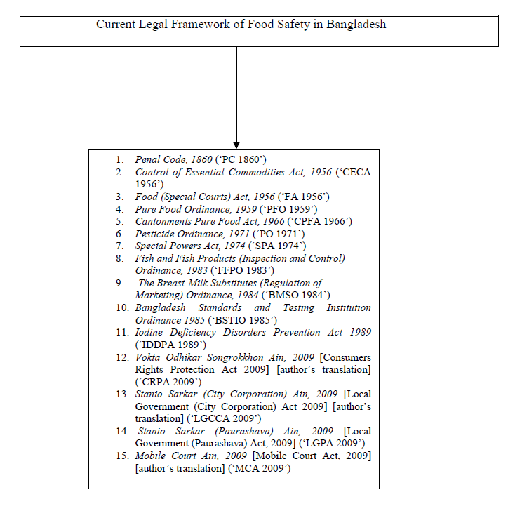

Figure: The legal framework of food safety of Bangladesh. [8]

Among the statutory laws, some laws are not actually used, while others cover very limited jurisdictions.

The laws listed in "Table 1" are implemented by various ministries and commissions and their subordinate agencies. The main institutions involved are the Congress, the United States Department of Agriculture (44), the United States Department of Agriculture, USDRD, MOLGRD, USDA. (MOI), Ministry of Fisheries and Livestock (MOFL), Ministry of Commerce (MOC), Ministry of Education (MOE) and Ministry of Interior (MOHA).

"Table 2" is a chart of Bangladesh's regulatory agencies addressing food safety issues.

**Table 2:**

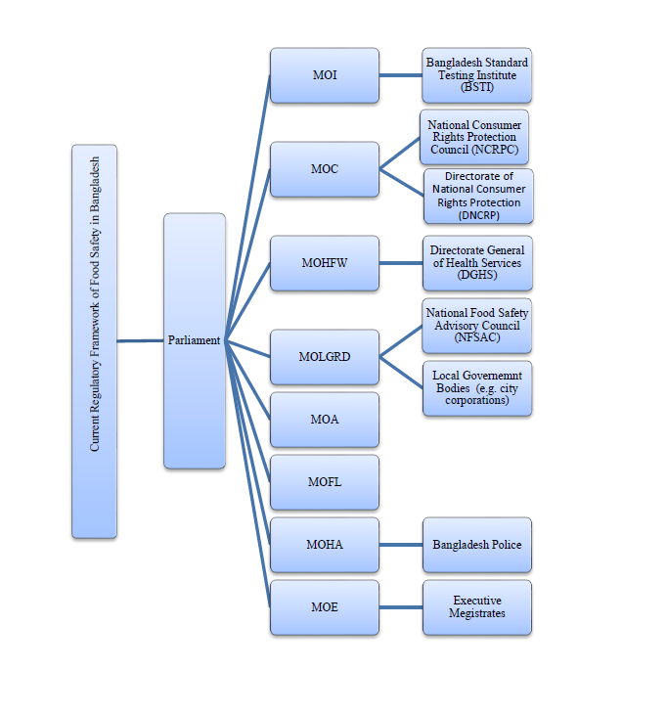

Figure: Bangladesh's regulatory agencies addressing food safety issues. [8]

**Drawbacks in the Legal and Regulatory Framework:**

The situations described in "Table 1" and "Table 2" of this manuscript usually mean that the entire food industry is blatantly ignoring Bangladesh's existing food regulations.[9] The lack of product and consumer information, as well as educational and cultural factors, may be the cause of existing food safety problems in Bangladesh.The FSRRB lacks many legal issues that have caused the overall regulatory framework to fail.

**a) Multiplicity of Laws:**

Table 1 shows that at least 15 laws (excluding common law clauses) regulate the current food safety legal framework in Bangladesh. It should be noted that it is quite rare to use so many laws for security purposes. Below are two examples.

First, Articles 272 and 273 of the Penal Code of 1860 criminalized counterfeiting food. PFO 1959 also pursues the same crime under Article 6 (1) (a) and prohibits counterfeiting in manufacturing. Later, in 1974, the Bolivian government included counterfeit food several times in the 1974 SPA, adding Article 25C, simply treating it as a phrase similar to punishment (in this case, the death penalty). The provisions of PC 1860. Although the three laws mentioned at the same time criminalize food counterfeiting, the Belize government issued the 2009 CRPA in 2009, where Article 41 again contains the same crime. [10]

Secondly, the use of pesticides containing DDT was controlled by the PO in 1971, but law enforcement agencies have the right to punish offenders who use the chemical DDT in food according to the aforementioned chapters of PC 1960, PFO 1959, SPA 1974 and CRPA 2009.

Excessive legislation has caused confusion in the minds of manufacturers, processors, retailers, and even law enforcement agencies trying to find out which law addresses specific food safety issues. In recognition of similar concerns in the UK, the Hampton Review cited an academic study in 2003 that found that "62% of small food business owners do not understand which food safety standards are relevant to them."

The above discussion shows that sometimes manufacturers and retailers may violate the law because of ignorance. Therefore, it can be said that the comprehensive laws in the FSRRB are essential to solve current food safety issues and can combine all the above-mentioned legislation to form a single food safety law.

**b) Non-coordination and Overlapping of Regulatory Bodies:**

Although there are several agencies in the FSRRB, as shown in Table 2, there is no effective coordination between these food safety regulatory agencies. [11] The NTFS mentioned that the Cabinet is the central coordination point for all matters in Bangladesh. 59 However, in reality, the Cabinet is overwhelmed by the numerous government activities coordinated by the supervisor on food safety issues. Section 4A describes the regulations of the coordinating agency. Section 4A of PFO 1959 provides for the establishment of the National Food Safety Advisory Committee (NFSAC) as the coordinating agency. [12]

However, NFSAC has many shortcomings, such as insufficient staff and lack of independent institutions in practice, making it useless.

Anti-fraud campaigns are carried out by various ministries in Bangladesh, some by the Ministry of Transport, some by the Ministry of Interior, and some by city companies (under MOLGRD). Or NFSAC coordinated follow-up actions. In fact, the whole situation is puzzling. It is difficult for manufacturers to understand who is really responsible for ensuring food safety and to whom they should be held accountable. A government spokesperson emphasized that the lack of coordination between Bolivian government agencies dealing with food safety issues [13] was one of the reasons for the failure of the entire food safety agreement in Bangladesh. [14]

**c) Transparency, Autonomy and Bureaucracy Issues:**

It is generally agreed that an adequate and effective legal framework should be based on transparency and accountability. This is because regulatory transparency covers the entire corporate governance infrastructure of a country. Regulators must be transparent both externally and internally. 70 Unfortunately, the regulatory agencies involved in the FSRRB have many members, especially government officials. NFSAC is part of MOLGRD. According to Article 4A (1) of the PFO in 1959, NFSAC has 15 members; 12 of them are government officials, including the ministers listed in "Table 2" and secretaries of various ministries and commissions. In addition, the opinions of consumers are not seriously considered here. Food safety is a sensitive issue, and citizens (consumers) are ready to participate in the decision-making process.

In addition, PFO 1959 does not contain NFSAC decision-making clauses. Minister MOLGRD is the former chairman and is essentially part of the political government, so political influence cannot be ignored when making decisions. Due to the lack of regulatory transparency, corruption has become a major problem in Bangladesh over the past two decades. [15]

Regulatory agencies under the FSRRB are very bureaucratic. For example, in 2009 CRPA Section 18, the National Consumer Protection Agency (DNCRP) was established to perform the functions of the law, but in 2009 CRPA Section 71 requires victims to be allowed to do so DNCRP caught up with the prosecution of the perpetrators. [16] This unnecessary bureaucracy ultimately invalidated such an important consumer protection law.

**d) Inadequacy of Penalties:**

An important factor of the FSRRB is the lack of sanctions; in fact, given the current counterfeiting situation, the question that now arises is whether the sanctions stipulated in the legislation are appropriate. Some examples are given below.

The penalties for counterfeiting food or beverages under Article 272 CC 1860 are up to 6 months imprisonment or up to 1,000 BDT (Bangladesh Taka) (equivalent to 10 Euros). [17] If the severity of the violation and the duration of imprisonment and the possible fines are taken into account, it can be said that this penalty may greatly exceed the possible fines of the 21st food manufacturer.

The PFO of 1959 was one of the most important laws prohibiting the production of dangerous food in Bangladesh; but unfortunately, the law also did not provide for appropriate sanctions. In 2005, the PFO was revised in 1959, and the penalties imposed increased significantly, but they were still insufficient. Compliance, content or quality is increased to BDD 50,000 (equivalent to 476 euros) or one year in prison. The maximum fine for subsequent violations of the same type is 200,000 BDT (corresponding to 1904) Or three years’ imprisonment, confiscating manufactured or stored products. The use of formalin (a toxic food coloring) in food manufacturing or processing can be punishable by a fine of up to 50,000 baht or one year's imprisonment (first violation); Any subsequent crimes of the same nature will result in a maximum fine of 200,000 baht or three years' imprisonment, confiscation of shops or factories, etc. 78. From Bangladesh’s perspective, for crimes such as counterfeiting food or adding formalin to food, a fine of 200,000 BDT or three years’ imprisonment should not be enough, and such counterfeiting is slowly killing millions of people every year.[18]

The penalties for violating CRPA 2009 are relatively high, but not enough. Article 37 states that if the person fails to pay the purchase price, the person will be sentenced to a maximum of one year’s imprisonment and/or a fine of 50,000 Brazilian dinars. According to the law, a person faces three years in prison and/or a fine of up to 200,000 Brazilian dinars for “mixing prohibited chemicals”80 (such as formalin) in food. The punishment for these crimes will be doubled. If the convicted person repeats the same crime.

Different from the above-mentioned light penalties, SPA 1974 imposes heavy penalties such as life imprisonment and death penalty on counterfeit food. 81 Although this punishment is also undesirable; the death penalty is a very cruel punishment for any crime. The use of the death penalty must be viewed from a human rights perspective because the Second Optional Protocol to the International Covenant on Civil and Political Rights proposes to abolish the death penalty from the civilized world.

e) **Enforcement Problems:**

In Bangladesh, sanctions are used for law enforcement, but there is a lack of convincing measures such as training, warnings, and notifications to improve law enforcement mechanisms. In addition, Bangladesh’s administrative law enforcement mechanism is not well organized. No control strategy has been developed, and there is no clear method to identify violations. In order to establish a better enforcement system, it is important to develop a clear overall implementation strategy so that all cases of non-compliance can be easily identified and the relevant authorities can take action. Appropriate measures. [19] There is no special law enforcement agency or official responsible for enforcing food safety regulations in Bangladesh. Generally speaking, MOHFW is responsible for food safety in Bangladesh and the compliance of laws is enforced by Sanitary Inspectors (SI). There are many things to do, and food safety is only a small part of your responsibility. Other SI or other regulatory agencies 84 Inspectors deployed to ensure food safety cannot sanction those responsible unless they are assisted by law enforcement officers from the Ministry of Education. However, this rarely arouses their interest, because their work schedule is very full, which is full of many management tasks. As a result, not only food safety inspection activities, but also regulatory compliance are constantly being hampered.

**Conclusion:**

An effective food safety regulatory framework is essential to ensure the food safety of consumers in the country, because Bangladesh has not had food safety for a long time, causing serious public health problems. Considering the current situation, the FSRRB can be recommended to call for the formulation of unified, well-written and up-to-date legislation to provide for an autonomous and highest food safety regulatory agency for various coordination. Accountability and transparency, without bureaucratic complications. The law needs to be amended to provide the most severe punishment for offenders, and to establish an effective law enforcement system based on reliable tools.

Refarence:

1. <https://www.who.int/news-room/fact-sheets/detail/food-safety>
2. <https://www.ncbi.nlm.nih.gov/pmc/articles/PMC4745531/>
3. Muinde O. K., Kuria E. Hygienic and sanitary practices of vendors of street foods in Nairobi, Kenya. African Journal of Food, Agriculture, Nutrition and Development*.*2005;5:1–13.
4. <http://wiego.org/informal-economy/occupational-groups/street-vendors>.
5. Consumer Association of Bangladesh (CAB) Institutionalization of Healthy Street Food System in Bangladesh: Safer street Foods: A Pilot Study with Three Wards of Dhaka City Corporation as a Model: 1-2. 2010.
6. Food and Agricultural Organization of the United Nations. Improving food safety, quality and food control in Bangladesh. Report—Seminar on Food Safety Challenges in Bangladesh, pp. 1–16, May 2010.
7. World Bank. Improving Living Conditions for the Urban Poor*.* Dhaka, Bangladesh: The World Bank Office; 2007.
8. Food safety and public health issues in Bangladesh: a regulatory
9. S. S. M. Sadrul Huda, Ahmed Taneem Muzaffar, and Jasim Uddin Ahmed, “An Enquiry into the Perception on Food Quality among Urban People: A Case of Bangladesh,” *African Journal of Business Management* 3 (2009): 228.
10. CRPA 2009, s 2(20)(b).
11. http://www.bdfoodsafety.org/admin/uploadimg/Rajshahi%20Inspection%20Workshop%20REPORT.pdf, 5.
12. http://www.bdfoodsafety.org/admin/uploadimg/file/Situation%20Analysis/Situation%20Analysis_Food%20Inspection%20in%20Bangladesh.pdf, 1.
13. See generally Abdur Rouf, “Bangladesh” (paper presented at the Study Meeting on Enhancing Food Certification Systems for Better Marketing, Tokyo, Japan, January 21–28, 2004), 93.
14. Hampton, Reducing Administrative Burdens, 59 [4.15].
15. http://www.un.org/wcm/webdav/site/ldc/shared/Bangladesh.pdf, 12.
16. Note: The problems regarding bureaucracy in Bangladesh can be understood from Huque, “Accountability and Governance,” 62–4.
17. The current EUR/ BDT rate is 1 Euro = 104.04 BDT. See Yahoo Finance at, http://finance.yahoo.com/q?s=EURBDT=X. Accessed January 4, 2013.
18. http://www.thedailystar.net/newdesign/news-details.php?Nid=136517.
19. See generally Robert Baldwin and Julia Black, “Really Responsive Regulation,” *The Modern Law Review* 71 (2008): 61.